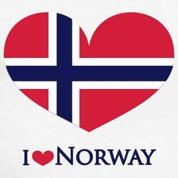
Norwegians Worldwide

Tucson chapter

newsletter –April 2020

  - April 2020

SSSave the dates
2020
16 February 2020 2:00 PM
5102 N Craycroft Rd, Tucson, AZ 85718 Lutheran Church in the Foothills
5102 N Craycroft Rd, Tucson, AZ 85718 5102 N Craycroft Rd, Tucson, AZ 85718

366666666

+
3114 E Fort Lowell Rd, Tucson, AZ 85716 3114 E Fort Lowell Rd, Tucson, AZ 85716.33333
…
Norsk Folk
Get together at
Mona’s Danish Bakery
4777 E Sunrise Dr # 113, Tucson, AZ 85718

Save the Dates
Next Meeting will be
September 20, 2020
2:00 PM
(Our new Location)
Our Saviour's Lutheran Church
1200 N Campbell Ave,
Tucson, AZ 85719
********
NORSK Folk Gathering
To be determined
OUR Website -
www.norse-tucson.org

Membership-Julia Olsen-
arizonanorse@gmail.com or TEXT or VOICE MESSAGE : (520) 276-9561‬
Our New address-PO Box 42166
Tucson AZ 85733
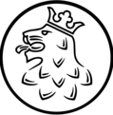
You may pay online with your
Credit card now at our new website
www.norse-tucson.org
Our board has made the difficult decision to cancel all meetings for April and May, including the Syttende mai breakfast. With many of us already in home quarantine, we do this with a heavy heart but believe ever so strongly that our collective health and safety should be pre-eminent.
We anticipate starting our fall meetings in September rather than October, but will keep you informed as we progress through the summer.
We have our Norwegian family and friends everywhere in our thoughts and prayers, and wish you all the best of health.
Norwegian Genealogy
Start with yourself
The first step is to start with what you know about yourself. Begin working backwards one generation at a time. Write down what you know and are able to verify for yourself: birth date and place, marriage date and place. Do the same for your spouse, children, grandchildren, parents, grandparents, great-grandparents, etc. Add the death date and place of death, if applicable.
Norwegian research is fairly easy once you get the hang of it. Records go back to the 1500s for most places. The trick often is finding where your immigrant ancestor came from in Norway.
How do I track down my ancestors?
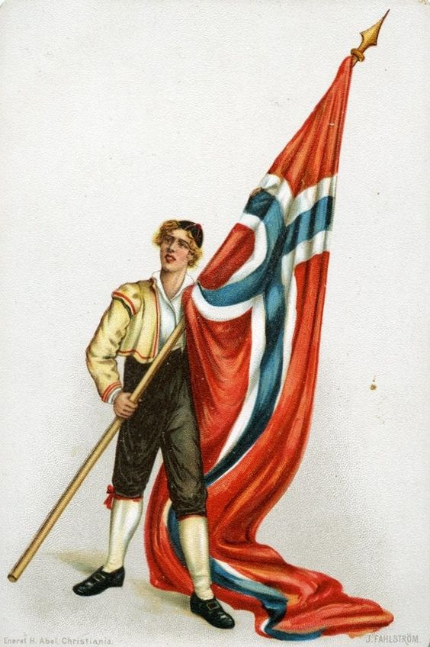
Norwegians have always loved keeping records, and chances are good that you’ll find the exact name, age and occupation of your Norwegian ancestors going back centuries. What happened to a person after he or she arrived in America, however, will not be recorded in Norwegian archives. To trace your lineage, you will need the name and birthplace of a relative born in Norway. Typically, this will be the person in your family who originally came over. In other words, in order to fully utilize Norwegian resources, you’ll need to do a little research at home first. Once you have a name, there are several sources available through which you can track his or her lineage. An understanding of old Norwegian naming customs will make your search easier.

Old Norwegian naming customs
Norwegian names today are composed of a first and last name, as in other western countries, but in the 19th century, a name acted as an important clue to someone’s place on the family tree. The typical 19th century Norwegian name would be composed of three parts: The given name, the patronymic and the farm name. Let’s take an example and break it down: Peder Johnsen Berg, a typical Norwegian farmer of the 1800s.
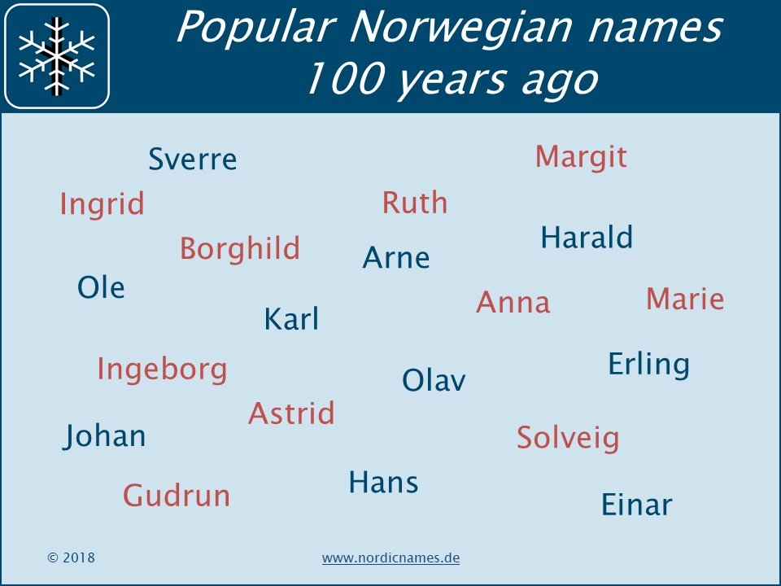
Given names were normally of Northern European origin, often adjusted to suit local dialects. Also, spelling was not standardized, meaning that Peter, Petter, Peder or Per may very well be the same person recorded by different clerks. The second name, the patronymic (Greek for “father’s name”), is what most people associate with Nordic names today. These are the names that end in “-sen” or “-son”, meaning “son of”, thereby communicating who your father was. Consequently, Peder Johnsen is the son of John. His sister will be called Johnsdatter (John’s daughter), and his son will be called Pedersen. Upon arrival in the States, this would commonly have been altered to Peterson. Two Petersons are therefore not necessarily related, they both just happened to have a father named Peter. People would also include a farm name. As with the patronymics, these were not names in the modern sense. They were more or less an address. If you moved, the name changed. If Peder moved from the Berg farm to the Vik farm, he would be known as Peder Johnsen Vik, or some variant spelling, from then on. Practically all farm names were derived from a defining geographical feature. The most widespread names in Norway even today are Berg (mountain or outcropping), Haug (hillock), Hagen (outfield) and Dal (valley). Compound names, like Øvreberg (Upper Berg) or Djupdal (Deep Valley), continue to be common.
By the early 1900s, the old naming system was fading away due to industrial development and urbanization. Its fate was sealed in 1925, when hereditary family names were made mandatory. To this day, most Norwegian last names are patronymics or farm names from that period.
Resources in the USA
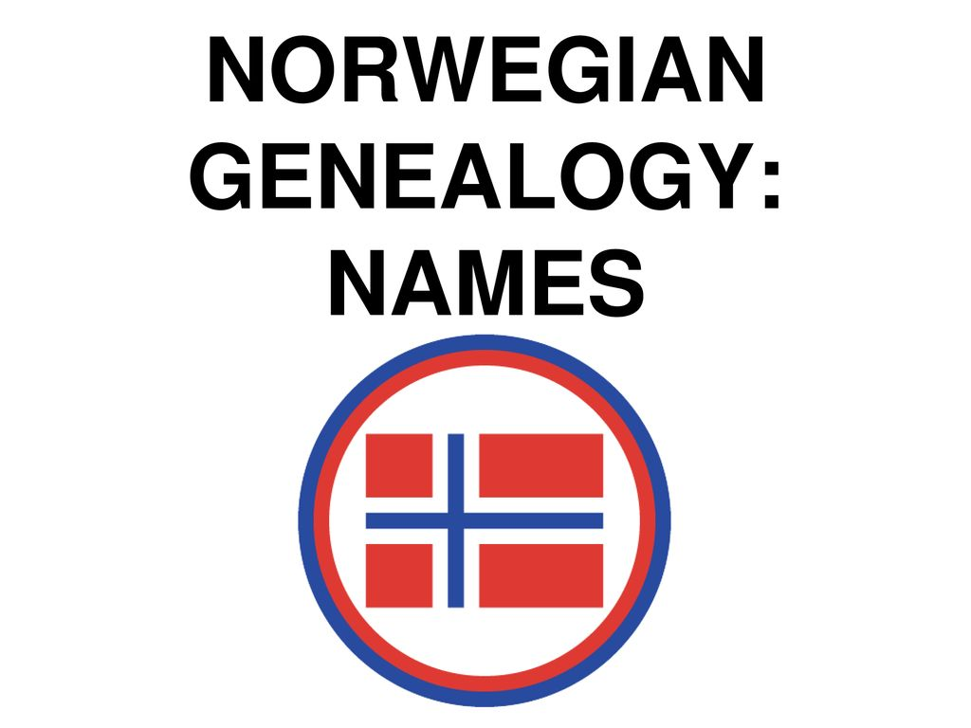
Ancestry.com (subscription site). Scanned and indexed ECLA (Evangelical Lutheran Church in America) church records – a large number of the Norwegian immigrants were Lutheran. These records include both births/baptisms, marriages, confirmations and often lists of the congregation.
Findagrave.com. A resource for burial places in the USA, sometimes accompanied by obituaries or memorials of the deceased that provide a birthplace or -date.
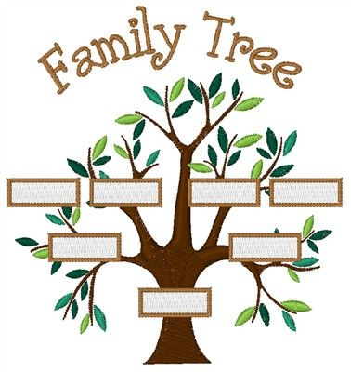
Familysearch.org (free). Indexed church records from Norway. These should be compared with the original scanned church records at arkivverket.no/digitalarkivet, as errors can occur in indexed material.
Norway—it’s the land of midnight sun and skies lit with brilliant bands of color from the northern lights, of stunningly beautiful fjords and majestic mountains, of bunads, brunost, and joik. Maybe it’s the land of your ancestors too!
You may see traits of your Norwegian ancestors in your life—for example, a strong sense of family and national identity, a love of nature, a desire to help those in need, and a willingness to work with others to reach a worthwhile goal. These traits are an integral part of Norwegian culture.
Your Norwegian heritage makes you part of a worldwide family that’s over 10 million strong, with over 5 million in Norway and the rest living in countries around the globe.
Welcome to your Norwegian Heritage
Norway’s Rich Past
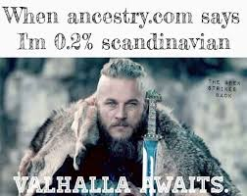
The known history of Norway starts around the 800s with the Vikings, who settled Norway and engaged in trade, travel, and conquest in surrounding areas. Conficts between Viking factions were frequent until, according to tradition, they were united by King Harald Fairhair in 872.
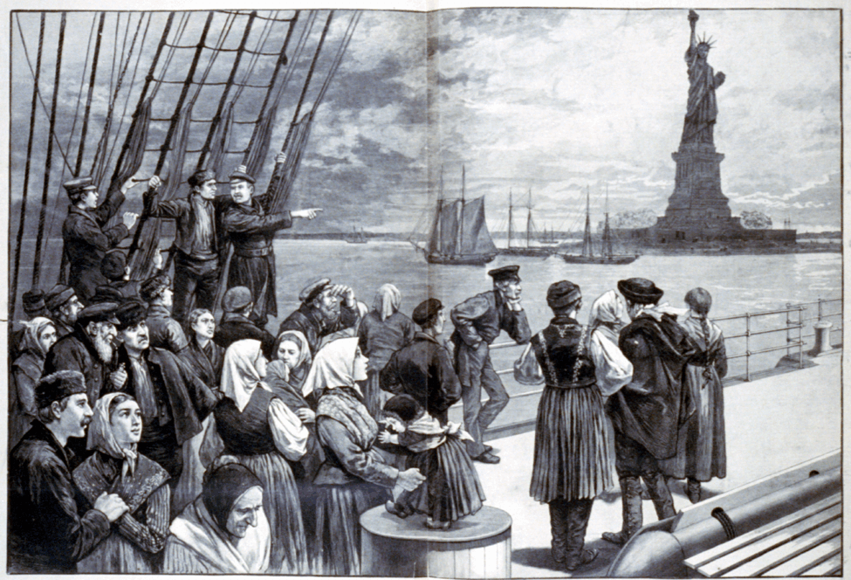
Christianity was introduced in Norway starting in the 1000s. After initial resistance from local leaders, it gained a firmer hold and was the dominant religion by the 1100s.
One of the great tragedies in Norwegian history was the Black Death or Great Plague, which devastated Europe and Asia in the 1300s. A year after it reached Norway in 1349, a third of the population had succumbed.
The Kalmar Union in 1397 unified Sweden, Norway, and Denmark. Sweden left the union in 1523, leaving Denmark and Norway under a single monarch. A series of wars ensued over the years, with Denmark ceding Norway to Sweden in January 1814. Later that year, on May 17, 1814, Norway sought independence by adopting a new constitution. However, they remained under Swedish rule until 1905, when Norway finally gained independence. Norwegians celebrate their independence each year on May 17, called “syttende mai” or Constitution Day.
Leaving Norway for a New Home
The earliest recorded Norwegian emigration—and perhaps the best known—took place under the leadership of Leif Erikson. His crew settled in what we know today as Newfoundland in Canada.
Emigration continued in the 1600s, with Norwegians joining Dutch colonists in New Amsterdam (present-day Manhattan Island in the United States), and in the 1700s as Norwegian Moravians came to Pennsylvania in the United States.
In 1825, 52 people left Norway aboard the ship Restaurationen to escape religious persecution. Their courageous journey across the Atlantic earned the respect of their new compatriots as well as those back home.
Emigration started in earnest 11 years later, as people were drawn to other lands by promises of opportunity, prosperity, and religious freedom. From 1836 to 1920, an estimated 900,000 people left Norway. They settled mainly in the United States and Canada, although significant numbers made new homes in Brazil, Canada, and the United Kingdom.
Do you want to learn more about your Norwegian heritage?
If you have hesitated to research your Norwegian genealogy, give it a try. Millions of online digitized records and many guides make tracing your family history easier than you can imagine. The key is to follow a good research strategy, learn about the available records, and make a record of where you look.
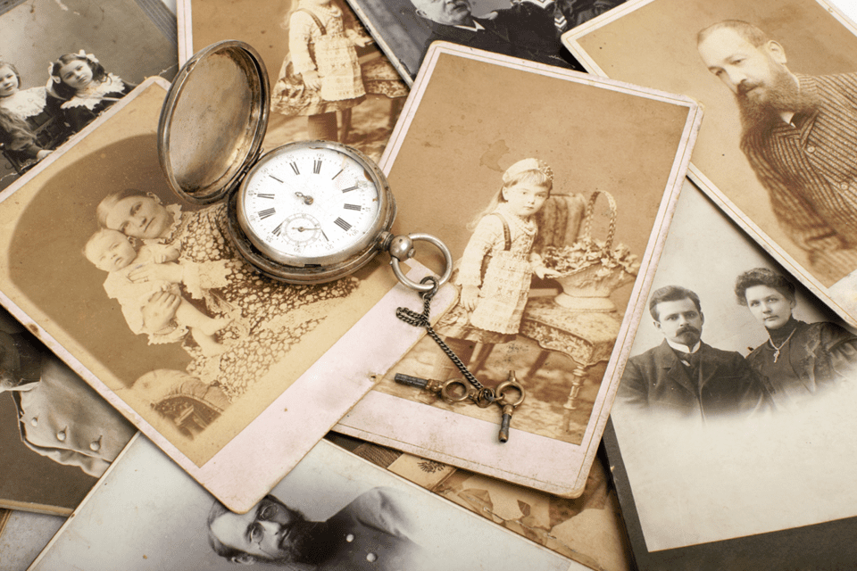
Your family may know more than you realize. Ask your living relatives about your family history—they may even have stories for you to record. Look for names, dates, and places on documents that may be gathering dust in an attic, inside a family Bible, or in an old photo album.
Join us for our monthly meetings where in the future we will be discussing our very own club’s Genealogy club within our club.
Ask us for more info how
we can help you.

VElkommen to your norwegian connection in the desert.
Norwegians Worldwide-Tucson Chapter
Contact Us
Norwegians Worldwide-Tucson
PO Box 42166
Tucson AZ 85733
520-301-9641
Email-NWW_Tucson@outlook.com
WWW. www.norse-tucson.org
Norwegians Worldwide-Tucson
PO Box 42166
Tucson AZ 85733
TO:

We are the TUCSON, Arizona chapter of Norwegians Worldwide / Nordmanns-Forbundet. Our chapter is a diverse network of Norwegian-Americans, Norwegians living here in Arizona, and anyone with an interest in Norway and Scandinavia. Founded as a registered non-profit organization, our chapter has been connecting our community and promoting the rich national and cultural heritage of Norway for over 40 years.
Welcome to a community for Norwegian Americans, Norwegians living in Arizona, and anyone with an interest in Norway and/or Scandinavia. If you are looking to connect with your heritage, practice your language skills, meet new friends, explore Nordic culture, and more -- drop us a line or stop by our next event! We host family-friendly events throughout the year celebrating Norway's rich cultural heritage and current events.
Join us online at
www.norse-tucson.org
